Nexelus Web Server

Server Setup

esm_logo.jpg

Nexelus USA  
New York, NEW YORK (NY)  
646-558-1950 ext.128

**1/25/2022**

# Document Information

The following table shows the details for document creation, review, approval, and effective date.

| **Category** | **Information** |
| --- | --- |
| Work Product: | Nexelus Web Server |
| Project Name: | Server Setup |
| Function Name: | Web Server Setup |
| Version: | 0.1 |
| Status: | Draft |
| Author(s): | Tauseef Shahzad |
| Reviewer(s): | Asim Jameel |
| Approver(s): | Imran Rahman |
| Control Status: | CONTROLLED, PROTECTED |
| Disclaimer: | This document contains confidential information. Do not distribute this document without prior approval from Nexelus. |

# Revision History

The following table is used for revision details of this document.

| **Author(s)** | **Date** | **Version** | **Description of Change** |
| --- | --- | --- | --- |
| Tauseef Shahzad | October 10, 2021 | 0.1 | Initial Draft |
|  |  |  |  |
|  |  |  |  |
|  |  |  |  |

# Table of Contents

Contents

[Document Information ii](#_Toc94006774)

[Revision History iii](#_Toc94006775)

[Table of Contents i](#_Toc94006776)

[Scope 1](#_Toc94006777)

[Windows Server Configurations 2](#_Toc94006778)

[Windows Roles and Features 3](#_Toc94006779)

[Additional Software 5](#_Toc94006780)

[IIS Pool and Websites 6](#_Toc94006781)

# Scope

Scope of this document is to list steps required to configure Nexelus Web Server

# Windows Server Configurations

This section provides Windows Server configurations and roles and features required to setup Web Server on Windows Server.

## Windows Roles and Features

1. Turn off Enhanced Security

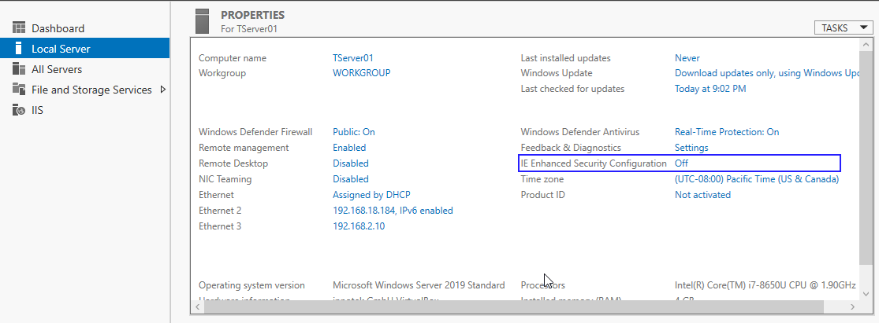

1. Setup Web Server and features
2. Install Web Server Role

1. Setup following features in Web server

## Additional Software

Install following Install dot Net Core setup files:

* dotnet-hosting-2.2.7-win
* dotnet-sdk-2.2.109-win-x64

## Copy files and information from Source Server

1. Login to existing web server
2. Create backup of websites and folders

[Asif azim]

1. Export Application Pools and Websites
2. Export Application Pools from IIS

From command prompt execute following command

*%windir%*\system32\inetsrv\appcmd list apppool /config /xml > c:\apppools.xml

1. Export Website configurations from IIS

From command prompt execute following command

*%windir%\system32\inetsrv\appcmd list site /config /xml > c:\websites.xml*

1. Create iisconfig.zip file for websites.xml and apppools.xml

## Setup files on new Server

Export Pool and Websites from existing server:

1. Copy backup folders on new server
2. Create file server links on new server

[Asif azim]

1. Install Crystal Reports

[Asif azim]

1. Configure econnect

[Asif azim]

1. Copy iisconfig.zip to new server and extract in a temp folder
2. Import Application Pools and Websites in new web server
3. Run following command on command prompt to import pools

*%windir%\system32\inetsrv\appcmd list apppool "CustomAppPool" /config /xml > customapppool.xml*

1. Run following command to import websites

*%windir%\system32\inetsrv\appcmd add apppool /in < c:\customapppool.xml*

1. Run following additional steps to finalize server setup

[Asif azim]